**ARUNAI ENGINEERING COLLEGE**

**(Affiliated to Anna University)**

**Velu Nagar,Thiruvannamalai-606603**

**www.arunai.org**

**DEPARTMENT OF COMPUTER SCIENCE & ENGINEERING**

**BACHELOR OF ENGINEERING**

**2023-2024**

**SIXTH SEMESTER**

**CCS356-OBJECT ORIENTED SOFTWARE ENGINEERING**

**CONTENT**

|  |  |  |  |
| --- | --- | --- | --- |
| **SN.NO** | **NAME OF THE CHAPTER** | **TITLE** | **PAGR NO** |
|  |  |  |  |
|  |  |  |  |
|  |  |  |  |
|  |  |  |  |
|  |  |  |  |
|  |  |  |  |
|  |  |  |  |
|  |  |  |  |
|  |  |  |  |
|  |  |  |  |
|  |  |  |  |
|  |  |  |  |
|  |  |  |  |
|  |  |  |  |
|  |  |  |  |
|  |  |  |  |
|  |  |  |  |
|  |  |  |  |
|  |  |  |  |
|  |  |  |  |
|  |  |  |  |
|  |  |  |  |
|  |  |  |  |
|  |  |  |  |

**CERTIFICATE**

**COLLEGE NAME**  **:** 5104 - ARUNAI ENGINEERING COLLEGE

**BRANCH**  **:** BE- COMPUTER SCIENCE AND ENGINEERING

**SEMESTER** **:** 6' SEMESTER (2023-2024)

**SUB CODE & NAME** **:** CCS356-OOSE

**:**

|  |  |  |  |
| --- | --- | --- | --- |
| **NAME OF THE STUDENTS** | **REGISTER NUMBER** | **TITLES OF THE PROJECT** | **NAME OF THE**  **GUIDE**  **DESIGNATION** |
| YUVARAJ.K  VIGNESH.K  VIJAYKUMAR.V  SURIYAMANI.G | 510421104120  510421104120  510421104120  510421104120 | BOOK BANK SYSTEM | Mrs.B.RUBA DEVI  B.E,M.TECH-CSE  Assistant Professor,  Department of CSE |

The report of the **MINI PROJECT** submitted for the fulfillment of Bachelor of engineering degree in **COMPUTER SCIENCE AND ENGINEERING** of Anna university was evaluated and confirmed to be report of the work done by the above student.

**ABSTRACT**

**Problem Statement:**

Clearly define the challenges faced with traditional book bank reservation systems, such as:

* Manual processes leading to inefficiencies and errors.
* Limited accessibility for users outside library hours.
* Difficulty in tracking book availability and reservation status.

**Project Objectives:**

Outline the goals of the online book bank reservation system, including:

* Streamlining the reservation process for improved efficiency.
* Providing 24/7 access for users to reserve books.
* Enabling real-time book availability tracking.
* Automating notifications for reservations and returns.

**Expected Outcomes:**

Briefly mention the anticipated benefits of the system, such as:

* Increased book availability and utilization.
* Reduced administrative workload.
* Enhanced user experience and satisfaction.

**Key Functionalities:**

Summarize the main features of the system, including:

* User registration and login
* Book search and browsing
* Online reservation requests
* Reservation approval/rejection management
* Book return management
* Reporting and analytics

**INTRODUCTION**

**Significance of Book Banks:**

Discuss the importance of book banks in educational settings, highlighting their role in:

* Providing affordable access to educational resources.
* Promoting literacy and knowledge sharing.
* Supporting students from underprivileged backgrounds.

**Limitations of Traditional Systems:**

Elaborate on the drawbacks of manual book bank reservation systems, such as:

* Time-consuming and error-prone processes.
* Limited availability during library hours.
* Difficulty in managing large numbers of books and reservations.
* Lack of real-time data on book availability.

**Advantages of Online System:**

Emphasize the benefits of an online book bank reservation system, including:

* Convenience and accessibility for users anytime, anywhere.
* Improved efficiency and accuracy through automation.
* Real-time book availability information.
* Reduced administrative workload through automation.
* Enhanced data management and reporting capabilities.

**Project Scope:**

Briefly outline the functionalities that will be implemented in the project, considering factors like:

* Target user groups (students, faculty, staff)
* Book types to be managed (textbooks, reference materials)
* Reservation duration and renewal options

**Hardware Requirements:**

**Server Requirements:**

Specify the minimum server specifications needed to handle:

* Expected number of concurrent users
* Database size and growth
* System performance requirements (processing power, memory, storage)

**Examples:**

Provide examples of suitable server hardware, such as:

**Processor:**

Intel Xeon, AMD EPYC (number of cores and clock speed)

RAM: Minimum 16GB DDR4, scalable based on user load

**Storage:**

RAID configuration for data redundancy and performance

**Network Requirements:**

Outline the network infrastructure needed for:

* Reliable internet connectivity
* Secure data transmission
* User access and communication

**Software Requirements**

**Programming Languages:**

Choose a suitable language based on:

Project complexity

* Developer expertise
* Integration with other technologies
* Examples: Python, Java, PHP

**Web Server:**

Select a web server for hosting the application, such as:

Apache, Nginx

**Database Management System (DBMS):**

Choose a DBMS for data storage and management, considering:

* Scalability
* Security features
* Examples: MySQL, PostgreSQL

**Development Frameworks (Optional):**

Utilize frameworks for faster development and code reusability, such as:

* Django (Python)
* Spring Boot (Java)

**Additional Libraries/Tools:**

Include any necessary libraries or tools for specific functionalities, such as:

* Authentication libraries for user login and security
* Email modules for sending notifications

**System Design**

**User Interface (UI) Design:**

Choose a web-based or mobile app approach based on user preferences and accessibility.

* Design user-friendly interfaces for:
* User registration and profile management
* Book search and browsing
* Reservation requests and tracking
* Return management
* Account settings and notifications
* Ensure clarity, responsiveness, and accessibility across different devices.

**Data Flow Diagrams:**

Create diagrams illustrating the flow of data between system components, including:

* User interactions with the UI
* Data processing within the system
* Communication with the database
* Use clear symbols and notations for easy understanding.

**Entity-Relationship Diagrams (ERDs):**

* Develop ERDs to represent entities (e.g., users, books, reservations) and their relationships.
* Show cardinalities (one-to-one, one-to-many, many-to-many) for data associations.

**System Modules:**

Define the main modules of the system and their functionalities, such as:

**User Management:**

User registration, login, profile management, user roles, access control

**Book Management:**

Book addition, editing, deletion, search, categorization, availability tracking

**Reservation Management:**

Reservation requests, approvals/rejections, notifications, return management, overdue book handling

**Reporting and Analytics:**

Generate reports on book availability, reservation trends, user activity, overdue books

**Security Considerations:**

Implement robust security measures to protect user data and system integrity, including:

* User authentication and authorization mechanisms
* Data encryption for sensitive information
* Secure data storage and access control
* Regular security audits and vulnerability assessments

**Scalability Considerations:**

Design the system with scalability in mind to accommodate future growth, such as:

* Modular architecture for easy addition of new features
* Database optimization for handling increased data volume
* Load balancing and distributed processing for handling more users

**Implementation & Testing**

**Development Methodology:**

Choose an appropriate development methodology based on project scope and team preferences, such as:

* **Agile:** Iterative and incremental development with continuous feedback
* **Waterfall:** Sequential development with clearly defined phases

**Development Environment Setup:**

* Configure the development environment with necessary tools, libraries, and frameworks.
* Ensure compatibility with chosen programming languages and technologies.

**Implementation Details:**

Provide detailed explanations of the implementation process for each module, including:

* **User Management:** User registration forms, login validation, user roles and permissions
* **Book Management:** Book data entry forms, search algorithms, availability tracking mechanisms
* **Reservation Management:** Reservation request forms, approval/rejection logic, notification systems, return management processes
* **Reporting and Analytics:** Data retrieval queries, report generation algorithms, data visualization tools

**Testing Strategies:**

Define a comprehensive testing strategy covering different aspects:

* **Unit testing:** Individual modules and functions
* **Integration testing:** Interactions between modules
* **System testing:** Overall system functionality and performance
* **User acceptance testing:** User experience and usability evaluation

**Testing Tools and Techniques:**

Utilize appropriate testing tools and techniques based on the chosen programming language and frameworks, such as:

* Unit testing frameworks (e.g., JUnit, PHPUnit)
* Integration testing tools (e.g., Selenium)
* Performance testing tools (e.g., LoadRunner)

**Defect Tracking and Resolution:**

* Establish a process for identifying, tracking, and resolving defects during testing.
* Utilize bug tracking tools or issue management systems.

**Development**

**User Management Module:**

* Explain the implementation details of user registration, login, profile management, and access control mechanisms.
* Discuss user roles and permissions for different user types (e.g., students, faculty, administrators).

**Book Management Module:**

* Describe how book data is added, edited, deleted, searched, and categorized within the system.
* Explain the implementation of book availability tracking mechanisms.

**Reservation Management Module:**

* Provide details on how users submit reservation requests, how administrators approve/reject requests, and how notification systems are implemented.
* Explain the return management process and overdue book handling mechanisms.

**Reporting and Analytics Module:**

* Discuss how the system retrieves data for generating reports on book availability, reservation trends, user activity, and overdue books.
* Explain the use of data visualization tools to present reports effectively.

**SOFTWARE REQUIREMENTS SPECIFICATION**

* The main purpose of creating the document about the software is to know about the list of the requirements that is required in the software project, part of the project to be developer.
* It specifies the requirements to develop a processing software part that complete the set of requirements.
* The students need the book for study about the subject, so student need to join the Book Bank. The Book Bank offers the student to take the required book for particular days and return it safely to the Book Bank after finish his course

**1. GLOSSARY**

* Generally a glossary is performed to define the entire domain used in the problem. It defines about the storage item that are familiar to the user membership card, it provide these definite. The data dictionary provide all the definition and information about the attribute we are using the particular project to the user.

**2. DEFINITION**

The glossary contains the working definition for the key concept in the Book

Bank system.

**3. MEMBERSHIP CARD ISSUE**

The Membership card is issued to the student when he joins the Book

Bank.

**4. PROFESSION**

The person who issues the book to the Student.

**5. SCOPE**

In this specification, we define about the system requirement that is apart from the functionality.

**6. FUNCTIONALITY**

Many member of the process line to check for its occurrence and transaction, we all have to carry over at sometime

**7. USABILITY**

The user interface to make the transaction should be effectively.

**8. PERFORMANCE**

It is the capability about which it can perform function for many users at the same time effectively without any error occurrence.

**UML DIAGRAMS**

**1. USE CASE DIAGRAM**

Use case is a sequence of transfer in a system whose task is to yield results of measurable value to individual action of the system. Use case is a set of sceneries of lied together by a common user goal. A sceneries is a sequence of step describing an interaction between a user and a system

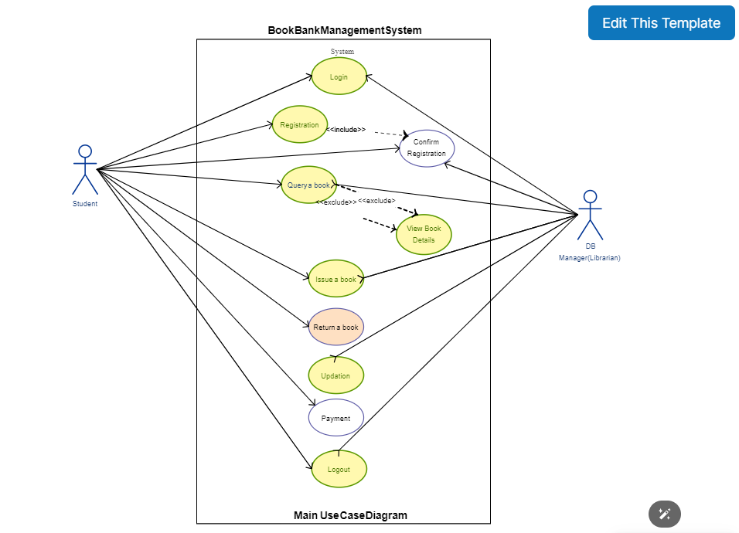

**DOCUMENTATION OF USE CASE DIAGRAM**

The use case diagram in the Book Bank illustrates the following sequence of steps. It is all for followed by the student and banker who are in charge of Book Bank.

**Enquiry**

The student wants to join the Book Bank for study about his subject. So he must enquire about the Book Bank rules and information about the Book Bank.

**Fill the form for join**

The Student fills the form and gets the Membership card

**Book details**

Then the student enquire about the Book details and fill the form for the require Book.

**Issuing the Book**

The Banker issue the Book which is mention in the form by the student.

**Collecting the book**

The student gets the Book and student about his subject by using this Book and returns it on the particular date.

**Database**

The Book Bank database was updated for each book issuing.

**2. CLASS DIAGRAM**

The class diagram describes the types of objects in the system and various

kinds if static relationship that exist among them

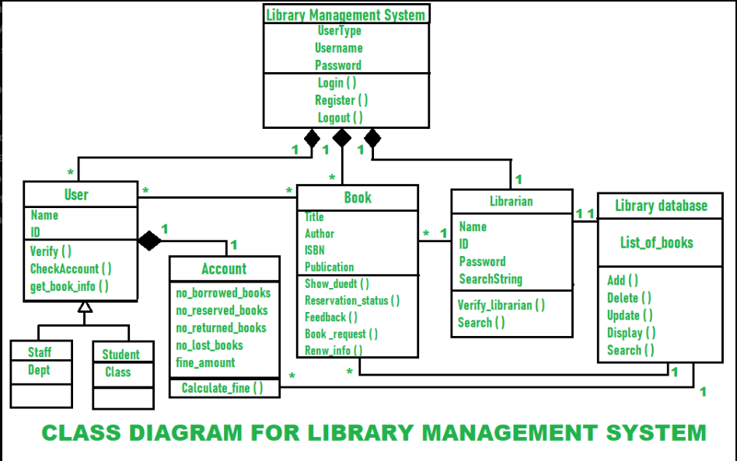

**DOCUMENTATION OF CLASS DIAGRAM**

The various classes involved in the system are registered

* The student enquire and join the Book bank
* Then student did he action of enquire , join , and collect
* The Book Bank did the action of checking , issuing , storing
* The student fill the form by fill his name, college name, course
* The bank issue the membership card to him, and he use this as a identity card
* The book bank have the attributes of its name and address
* It issue the book to student and get it back in the particular date

**3. INTERACTION DIAGRAM**

Interaction diagram are diagram that describes how groups of objects collaborate to get the job done. Interaction diagram capture the behavior of a single use case showing the pattern of interaction among object.

**3.1. SEQUENCE DIAGRAM**

A sequence diagram is one that includes the object of the project and

tells the left line and also various act performed behavior object

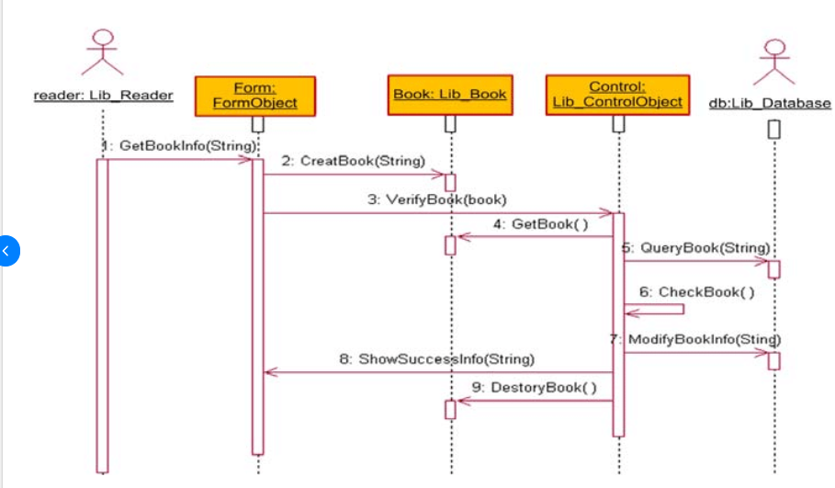

**DOCUMENTATION OF SEQUENCE DIAGRAM**

The single use case in the Book Bank process is taken and various

operations followed in use case.

* In this sequence ,the student enquire the Book Bank detail from the
* Banker and known about the Bank
* Then the student fill the form for join the book bank and require the
* book from the Book Bank
* The Banker check the book which is request the student is available or

not

* If the book is available, the Banker issue the Book to the student
* Then the Book bank database is update when the book is returned

**3.2. COLLABORATION DIAGRAM**

It is same as the sequence diagram that involve the project with only

difference, that we give sequence number to each diagram

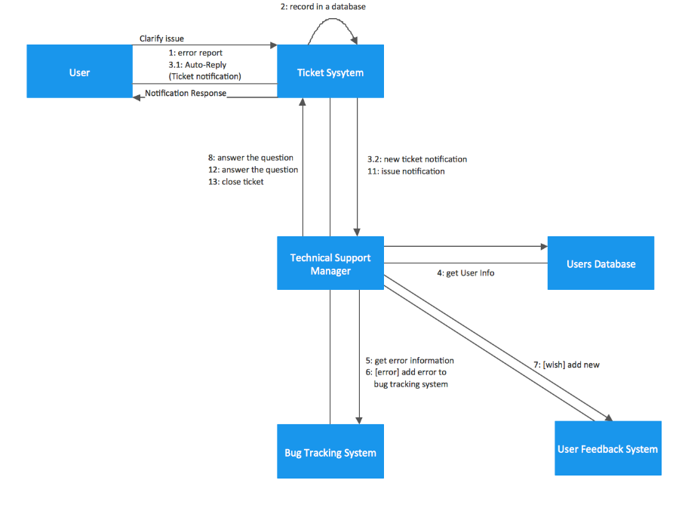

**DOCUMENTATION OF COLLABORATION DIAGRAM**

The sequence steps is

* Enquire the information about the book bank and join the bank
* Request the book from the banker
* The banker check the availability
* Then issue the available book to the student
* The database was updated

**4. STATE CHART DIAGRAM**

It is a technology to describe the behavior of the system. It describes all of the possible state that a particular object gets into the object oriented technique. State diagram are drawn for a single class to show the left time behavior of a single object

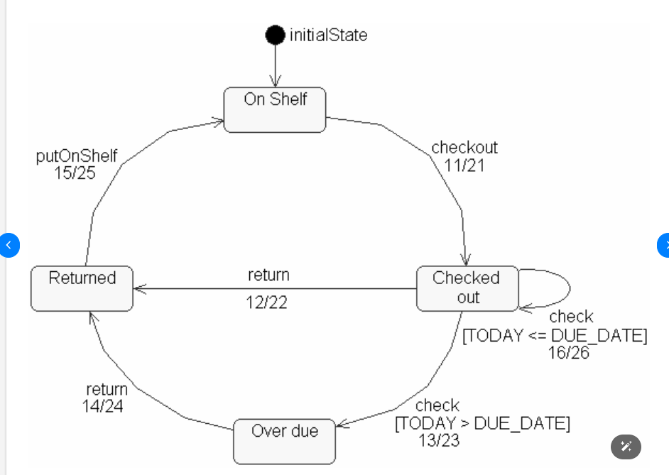

**DOCUMENTATION OF STATECHART DIAGRAM**

The state diagram describes the behavior of the system.

* The main purpose is to get the book from the book bank
* After getting the book the student study that and return it to the bank
* In between the student enquire and join the book bank and get the

membership card

* Then he use this card and get the book from the book bank

**5.ACTIVITY DIAGRAM**

It involves all the activities of particular project and the various step using join and far be. The activity diagram describes the operations that are carried out by analysis system. It involves the activities and there are various steps using joins and forks.

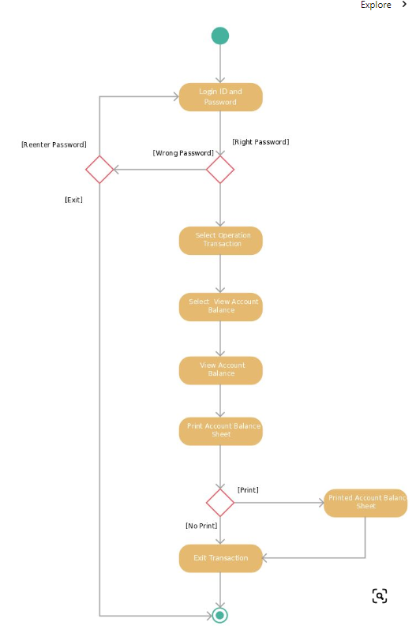

**DOCUMENTATION OF ACTIVITY DIAGRAM**

The student enquires about the book bank. Then he fills the form for join. Then he gets the book from the book bank. Safely return it in the particular date

**6. COMPONENT DIAGRAM**

The component diagram is represented by figure dependency and it is a graph of design of figure dependency

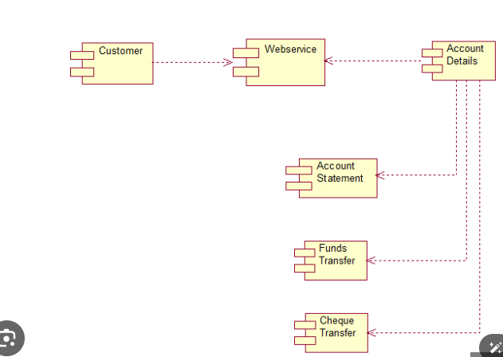

**DOCUMENTATION OF COMPONENT DIAGRAM**

This is component diagram represents the dependences that are present in the Book Bank system.

**7. DEPLOYMENT DIAGRAM:**

It is a graph of nodes connected by communication association. It is represented by three dimensional box

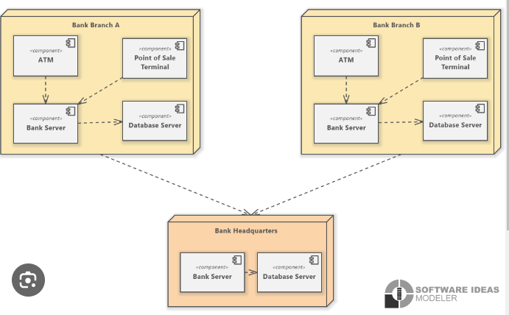

**DOCUMENTATION OF PACKAGE DIAGRAM**

The Package diagram has the functions like use case diagram. But it is have three layers of user interface layer, domain layer and the technical layer. In user interface layer book bank and student classes are there. Domain layer have the functions of the student and book bank. Technical layer have the technical of the above function.

**SOURCE CODE**

**<!DOCTYPE html>**

**<html lang="en">**

**<head>**

**<meta charset="utf-8">**

**<meta content="width=device-width, initial-scale=1.0" name="viewport">**

**<title>BOOK BANK SYSTEM</title>**

**<meta content="" name="description">**

**<meta content="" name="keywords">**

**<!-- Favicons -->**

**<link href="assets/img/favicon.png" rel="icon">**

**<link href="assets/img/apple-touch-icon.png" rel="apple-touch-icon">**

**<!-- Google Fonts -->**

**<link rel="preconnect" href="https://fonts.googleapis.com">**

**<link rel="preconnect" href="https://fonts.gstatic.com" crossorigin>**

**<link href="https://fonts.googleapis.com/css2?family=Open+Sans:ital,wght@0,300;0,400;0,500;0,600;0,700;1,300;1,400;1,600;1,700&family=Amatic+SC:ital,wght@0,300;0,400;0,500;0,600;0,700;1,300;1,400;1,500;1,600;1,700&family=Inter:ital,wght@0,300;0,400;0,500;0,600;0,700;1,300;1,400;1,500;1,600;1,700&display=swap" rel="stylesheet">**

**<!-- Vendor CSS Files -->**

**<link href="assets/vendor/bootstrap/css/bootstrap.min.css" rel="stylesheet">**

**<link href="assets/vendor/bootstrap-icons/bootstrap-icons.css" rel="stylesheet">**

**<link href="assets/vendor/aos/aos.css" rel="stylesheet">**

**<link href="assets/vendor/glightbox/css/glightbox.min.css" rel="stylesheet">**

**<link href="assets/vendor/swiper/swiper-bundle.min.css" rel="stylesheet">**

**<!-- Template Main CSS File -->**

**<link href="assets/css/main.css" rel="stylesheet">**

**<!-- =======================================================**

**\* Template Name: Yummy**

**\* Template URL: https://bootstrapmade.com/yummy-bootstrap-restaurant-website-template/**

**\* Updated: Mar 17 2024 with Bootstrap v5.3.3**

**\* Author: BootstrapMade.com**

**\* License: https://bootstrapmade.com/license/**

**======================================================== -->**

**</head>**

**<body>**

**<!-- ======= Header ======= -->**

**<header id="header" class="header fixed-top d-flex align-items-center">**

**<div class="container d-flex align-items-center justify-content-between">**

**<a href="index.html" class="logo d-flex align-items-center me-auto me-lg-0">**

**<!-- Uncomment the line below if you also wish to use an image logo -->**

**<!-- <img src="assets/img/logo.png" alt=""> -->**

**<h1>Yuvi<span>.</span></h1>**

**</a>**

**<nav id="navbar" class="navbar">**

**<ul>**

**<li><a href="#hero">Home</a></li>**

**<li><a href="#about">About</a></li>**

**<li><a href="login.html">log In</a></li>**

**<li><a href="signup.html">Sign Up</a></li>**

**<!-- <li><a href="#about">About</a></li>**

**<li><a href="#gallery">menu</a></li> -->**

**<!-- <li><a href="#events"></a></li> -->**

**<li class="dropdown"><a href="#"><span>Languages</span> <i class="bi bi-chevron-down dropdown-indicator"></i></a>**

**<ul>**

**<!-- <li><a href="#">Languages</a></li> -->**

**<!-- <li class="dropdown"><a href="#"><span>Languages</span> <i class="bi bi-chevron-down dropdown-indicator"></i></a> -->**

**<!-- <ul>**

**<li><a href="#">Tamil</a></li>**

**<li><a href="#">English</a></li>**

**<li><a href="#">Hindi</a></li>**

**<li><a href="#">Spanish</a></li>**

**<li><a href="#">German</a></li>**

**</ul> -->**

**</li>**

**<li><a href="#">Tamil</a></li>**

**<li><a href="#">English</a></li>**

**<li><a href="#">Hindi</a></li>**

**<li><a href="#">Spanish</a></li>**

**<li><a href="#">German</a></li>**

**</ul>**

**</li>**

**<li><a href="#gallery">Menu</a></li>**

**<li><a href="#contact">Contact</a></li>**

**</ul>**

**</nav><!-- .navbar -->**

**<a class="btn-book-a-table" href="#book-a-table">Book a BOOK</a>**

**<i class="mobile-nav-toggle mobile-nav-show bi bi-list"></i>**

**<i class="mobile-nav-toggle mobile-nav-hide d-none bi bi-x"></i>**

**</div>**

**</header><!-- End Header -->**

**<!-- ======= Hero Section ======= -->**

**<section id="hero" class="hero d-flex align-items-center section-bg">**

**<div class="container">**

**<div class="row justify-content-between gy-5">**

**<div class="col-lg-5 order-2 order-lg-1 d-flex flex-column justify-content-center align-items-center align-items-lg-start text-center text-lg-start">**

**<h2 data-aos="fade-up">Select the book <br>Quality of contant</h2>**

**<p data-aos="fade-up" data-aos-delay="100">Empowering communities through access: the Book Bank System, fostering literacy one borrowed book at a time.</p>**

**<div class="d-flex" data-aos="fade-up" data-aos-delay="200">**

**<a href="#book-a-table" class="btn-book-a-table">Reserve the book</a>**

**<a href="https://www.youtube.com/watch?v=LXb3EKWsInQ" class="glightbox btn-watch-video d-flex align-items-center"><i class="bi bi-play-circle"></i><span>Watch Video</span></a>**

**</div>**

**</div>**

**<div class="col-lg-5 order-1 order-lg-2 text-center text-lg-start">**

**<img src="https://images.rawpixel.com/image_800/czNmcy1wcml2YXRlL3Jhd3BpeGVsX2ltYWdlcy93ZWJzaXRlX2NvbnRlbnQvbHIvd2s3MTU5MTYwNy1pbWFnZS1rcHFub2NrMi5qcGc.jpg" class="img-fluid" alt="" data-aos="zoom-out" data-aos-delay="300">**

**</div>**

**</div>**

**</div>**

**</section><!-- End Hero Section -->**

**<main id="main">**

**<!-- ======= About Section ======= -->**

**<section id="about" class="about">**

**<div class="container" data-aos="fade-up">**

**<div class="section-header">**

**<h2>About Us</h2>**

**<p>Learn More <span>About Us</span></p>**

**</div>**

**<div class="row gy-4">**

**<div class="col-lg-7 position-relative about-img" style="background-image: url(https://images.unsplash.com/photo-1579370318443-8da816457e3d?q=80&w=1000&auto=format&fit=crop&ixlib=rb-4.0.3&ixid=M3wxMjA3fDB8MHxzZWFyY2h8MTF8fGxpYnJhcnklMjBib29rc3xlbnwwfHwwfHx8MA%3D%3D) ;" data-aos="fade-up" data-aos-delay="150">**

**<div class="call-us position-absolute">**

**<h4>Reserve a book</h4>**

**<p>+91 120 143 107</p>**

**</div>**

**</div>**

**<div class="col-lg-5 d-flex align-items-end" data-aos="fade-up" data-aos-delay="300">**

**<div class="content ps-0 ps-lg-5">**

**<p class="fst-italic">**

**Welcome to Yuvi , where we believe in the power of knowledge and the transformative impact of books. Founded with a vision to make literature accessible to all, we strive to foster a community passionate about reading and learning.**

**</p>**

**<ul>**

**<li><i class="bi bi-check2-all"></i> At Yuvi, our mission is simple yet profound: to bridge the gap between book lovers and the stories they seek. Whether you're a student eager to explore new realms of knowledge, a bibliophile in pursuit of literary treasures, or a community member seeking resources to enrich your life, we're here to serve you.</li>**

**<li><i class="bi bi-check2-all"></i> With a diverse collection spanning genres, languages, and topics, we aim to cater to every interest and age group. From timeless classics to contemporary bestsellers, educational resources to niche publications, our shelves are stocked with a plethora of titles waiting to be discovered.</li>**

**<!-- <li><i class="bi bi-check2-all"></i> Ullamco laboris nisi ut aliquip ex ea commodo consequat. Duis aute irure dolor in reprehenderit in voluptate trideta storacalaperda mastiro dolore eu fugiat nulla pariatur.</li> -->**

**</ul>**

**<!-- <p>**

**Ullamco laboris nisi ut aliquip ex ea commodo consequat. Duis aute irure dolor in reprehenderit in voluptate**

**velit esse cillum dolore eu fugiat nulla pariatur. Excepteur sint occaecat cupidatat non proident**

**</p> -->**

**<div class="position-relative mt-4">**

**<img src="https://media.istockphoto.com/id/949118068/photo/books.jpg?s=612x612&w=0&k=20&c=1vbRHaA_aOl9tLIy6P2UANqQ27KQ_gSF-BH0sUjQ730=" class="img-fluid" alt="">**

**<a href="https://www.youtube.com/watch?v=LXb3EKWsInQ" class="glightbox play-btn"></a>**

**</div>**

**</div>**

**</div>**

**</div>**

**</div>**

**</section><!-- End About Section -->**

**<!-- ======= Why Us Section ======= -->**

**<section id="why-us" class="why-us section-bg">**

**<div class="container" data-aos="fade-up">**

**<div class="row gy-4">**

**<div class="col-lg-4" data-aos="fade-up" data-aos-delay="100">**

**<div class="why-box">**

**<h3>Why Choose Yummy?</h3>**

**<p>**

**Lorem ipsum dolor sit amet, consectetur adipiscing elit, sed do eiusmod tempor incididunt ut labore et dolore magna aliqua. Duis aute irure dolor in reprehenderit**

**Asperiores dolores sed et. Tenetur quia eos. Autem tempore quibusdam vel necessitatibus optio ad corporis.**

**</p>**

**<div class="text-center">**

**<a href="#" class="more-btn">Learn More <i class="bx bx-chevron-right"></i></a>**

**</div>**

**</div>**

**</div><!-- End Why Box -->**

**<div class="col-lg-8 d-flex align-items-center">**

**<div class="row gy-4">**

**<div class="col-xl-4" data-aos="fade-up" data-aos-delay="200">**

**<div class="icon-box d-flex flex-column justify-content-center align-items-center">**

**<i class="bi bi-clipboard-data"></i>**

**<h4>Corporis voluptates officia eiusmod</h4>**

**<p>Consequuntur sunt aut quasi enim aliquam quae harum pariatur laboris nisi ut aliquip</p>**

**</div>**

**</div><!-- End Icon Box -->**

**<div class="col-xl-4" data-aos="fade-up" data-aos-delay="300">**

**<div class="icon-box d-flex flex-column justify-content-center align-items-center">**

**<i class="bi bi-gem"></i>**

**<h4>Ullamco laboris ladore pan</h4>**

**<p>Excepteur sint occaecat cupidatat non proident, sunt in culpa qui officia deserunt</p>**

**</div>**

**</div><!-- End Icon Box -->**

**<div class="col-xl-4" data-aos="fade-up" data-aos-delay="400">**

**<div class="icon-box d-flex flex-column justify-content-center align-items-center">**

**<i class="bi bi-inboxes"></i>**

**<h4>Labore consequatur incidid dolore</h4>**

**<p>Aut suscipit aut cum nemo deleniti aut omnis. Doloribus ut maiores omnis facere</p>**

**</div>**

**</div><!-- End Icon Box -->**

**</div>**

**</div>**

**</div>**

**</div>**

**</section><!-- End Why Us Section -->**

**<!-- ======= Stats Counter Section ======= -->**

**<section id="stats-counter" class="stats-counter">**

**<div class="container" data-aos="zoom-out">**

**<div class="row gy-4">**

**<div class="col-lg-3 col-md-6">**

**<div class="stats-item text-center w-100 h-100">**

**<span data-purecounter-start="0" data-purecounter-end="232" data-purecounter-duration="1" class="purecounter"></span>**

**<p>Clients</p>**

**</div>**

**</div><!-- End Stats Item -->**

**<div class="col-lg-3 col-md-6">**

**<div class="stats-item text-center w-100 h-100">**

**<span data-purecounter-start="0" data-purecounter-end="521" data-purecounter-duration="1" class="purecounter"></span>**

**<p>Projects</p>**

**</div>**

**</div><!-- End Stats Item -->**

**<div class="col-lg-3 col-md-6">**

**<div class="stats-item text-center w-100 h-100">**

**<span data-purecounter-start="0" data-purecounter-end="1453" data-purecounter-duration="1" class="purecounter"></span>**

**<p>Hours Of Support</p>**

**</div>**

**</div><!-- End Stats Item -->**

**<div class="col-lg-3 col-md-6">**

**<div class="stats-item text-center w-100 h-100">**

**<span data-purecounter-start="0" data-purecounter-end="32" data-purecounter-duration="1" class="purecounter"></span>**

**<p>Workers</p>**

**</div>**

**</div><!-- End Stats Item -->**

**</div>**

**</div>**

**</section><!-- End Stats Counter Section -->**

**<!-- ======= Menu Section ======= -->**

**<section id="menu" class="menu">**

**<div>**

**</div>**

**<div class="container" data-aos="fade-up">**

**<div class="section-header">**

**<h2>Our Menu</h2>**

**<p>Check Our <span>Yummy Menu</span></p>**

**</div>**

**<ul class="nav nav-tabs d-flex justify-content-center" data-aos="fade-up" data-aos-delay="200">**

**<li class="nav-item">**

**<a class="nav-link active show" data-bs-toggle="tab" data-bs-target="#menu-starters">**

**<h4>Starters</h4>**

**</a>**

**</li><!-- End tab nav item -->**

**<li class="nav-item">**

**<a class="nav-link" data-bs-toggle="tab" data-bs-target="#menu-breakfast">**

**<h4>Breakfast</h4>**

**</a><!-- End tab nav item -->**

**<li class="nav-item">**

**<a class="nav-link" data-bs-toggle="tab" data-bs-target="#menu-lunch">**

**<h4>Lunch</h4>**

**</a>**

**</li><!-- End tab nav item -->**

**<li class="nav-item">**

**<a class="nav-link" data-bs-toggle="tab" data-bs-target="#menu-dinner">**

**<h4>Dinner</h4>**

**</a>**

**</li><!-- End tab nav item -->**

**</ul>**

**<div class="tab-content" data-aos="fade-up" data-aos-delay="300">**

**<div class="tab-pane fade active show" id="menu-starters">**

**<div class="tab-header text-center">**

**<p>Menu</p>**

**<h3>Starters</h3>**

**</div>**

**<div class="row gy-5">**

**<div class="col-lg-4 menu-item">**

**<a href="assets/img/menu/menu-item-1.png" class="glightbox"><img src="assets/img/menu/menu-item-1.png" class="menu-img img-fluid" alt=""></a>**

**<h4>Magnam Tiste</h4>**

**<p class="ingredients">**

**Lorem, deren, trataro, filede, nerada**

**</p>**

**<p class="price">**

**$5.95**

**</p>**

**</div><!-- Menu Item -->**

**<div class="col-lg-4 menu-item">**

**<a href="assets/img/menu/menu-item-2.png" class="glightbox"><img src="assets/img/menu/menu-item-2.png" class="menu-img img-fluid" alt=""></a>**

**<h4>Aut Luia</h4>**

**<p class="ingredients">**

**Lorem, deren, trataro, filede, nerada**

**</p>**

**<p class="price">**

**$14.95**

**</p>**

**</div><!-- Menu Item -->**

**<div class="col-lg-4 menu-item">**

**<a href="assets/img/menu/menu-item-3.png" class="glightbox"><img src="assets/img/menu/menu-item-3.png" class="menu-img img-fluid" alt=""></a>**

**<h4>Est Eligendi</h4>**

**<p class="ingredients">**

**Lorem, deren, trataro, filede, nerada**

**</p>**

**<p class="price">**

**$8.95**

**</p>**

**</div><!-- Menu Item -->**

**<div class="col-lg-4 menu-item">**

**<a href="assets/img/menu/menu-item-4.png" class="glightbox"><img src="assets/img/menu/menu-item-4.png" class="menu-img img-fluid" alt=""></a>**

**<h4>Eos Luibusdam</h4>**

**<p class="ingredients">**

**Lorem, deren, trataro, filede, nerada**

**</p>**

**<p class="price">**

**$12.95**

**</p>**

**</div><!-- Menu Item -->**

**<div class="col-lg-4 menu-item">**

**<a href="assets/img/menu/menu-item-5.png" class="glightbox"><img src="assets/img/menu/menu-item-5.png" class="menu-img img-fluid" alt=""></a>**

**<h4>Eos Luibusdam</h4>**

**<p class="ingredients">**

**Lorem, deren, trataro, filede, nerada**

**</p>**

**<p class="price">**

**$12.95**

**</p>**

**</div><!-- Menu Item -->**

**<div class="col-lg-4 menu-item">**

**<a href="assets/img/menu/menu-item-6.png" class="glightbox"><img src="assets/img/menu/menu-item-6.png" class="menu-img img-fluid" alt=""></a>**

**<h4>Laboriosam Direva</h4>**

**<p class="ingredients">**

**Lorem, deren, trataro, filede, nerada**

**</p>**

**<p class="price">**

**$9.95**

**</p>**

**</div><!-- Menu Item -->**

**</div>**

**</div><!-- End Starter Menu Content -->**

**<div class="tab-pane fade" id="menu-breakfast">**

**<div class="tab-header text-center">**

**<p>Menu</p>**

**<h3>Breakfast</h3>**

**</div>**

**<div class="row gy-5">**

**<div class="col-lg-4 menu-item">**

**<a href="assets/img/menu/menu-item-1.png" class="glightbox"><img src="assets/img/menu/menu-item-1.png" class="menu-img img-fluid" alt=""></a>**

**<h4>Magnam Tiste</h4>**

**<p class="ingredients">**

**Lorem, deren, trataro, filede, nerada**

**</p>**

**<p class="price">**

**$5.95**

**</p>**

**</div><!-- Menu Item -->**

**<div class="col-lg-4 menu-item">**

**<a href="assets/img/menu/menu-item-2.png" class="glightbox"><img src="assets/img/menu/menu-item-2.png" class="menu-img img-fluid" alt=""></a>**

**<h4>Aut Luia</h4>**

**<p class="ingredients">**

**Lorem, deren, trataro, filede, nerada**

**</p>**

**<p class="price">**

**$14.95**

**</p>**

**</div><!-- Menu Item -->**

**<div class="col-lg-4 menu-item">**

**<a href="assets/img/menu/menu-item-3.png" class="glightbox"><img src="assets/img/menu/menu-item-3.png" class="menu-img img-fluid" alt=""></a>**

**<h4>Est Eligendi</h4>**

**<p class="ingredients">**

**Lorem, deren, trataro, filede, nerada**

**</p>**

**<p class="price">**

**$8.95**

**</p>**

**</div><!-- Menu Item -->**

**<div class="col-lg-4 menu-item">**

**<a href="assets/img/menu/menu-item-4.png" class="glightbox"><img src="assets/img/menu/menu-item-4.png" class="menu-img img-fluid" alt=""></a>**

**<h4>Eos Luibusdam</h4>**

**<p class="ingredients">**

**Lorem, deren, trataro, filede, nerada**

**</p>**

**<p class="price">**

**$12.95**

**</p>**

**</div><!-- Menu Item -->**

**<div class="col-lg-4 menu-item">**

**<a href="assets/img/menu/menu-item-5.png" class="glightbox"><img src="assets/img/menu/menu-item-5.png" class="menu-img img-fluid" alt=""></a>**

**<h4>Eos Luibusdam</h4>**

**<p class="ingredients">**

**Lorem, deren, trataro, filede, nerada**

**</p>**

**<p class="price">**

**$12.95**

**</p>**

**</div><!-- Menu Item -->**

**<div class="col-lg-4 menu-item">**

**<a href="assets/img/menu/menu-item-6.png" class="glightbox"><img src="assets/img/menu/menu-item-6.png" class="menu-img img-fluid" alt=""></a>**

**<h4>Laboriosam Direva</h4>**

**<p class="ingredients">**

**Lorem, deren, trataro, filede, nerada**

**</p>**

**<p class="price">**

**$9.95**

**</p>**

**</div><!-- Menu Item -->**

**</div>**

**</div><!-- End Breakfast Menu Content -->**

**<div class="tab-pane fade" id="menu-lunch">**

**<div class="tab-header text-center">**

**<p>Menu</p>**

**<h3>Lunch</h3>**

**</div>**

**<div class="row gy-5">**

**<div class="col-lg-4 menu-item">**

**<a href="assets/img/menu/menu-item-1.png" class="glightbox"><img src="assets/img/menu/menu-item-1.png" class="menu-img img-fluid" alt=""></a>**

**<h4>Magnam Tiste</h4>**

**<p class="ingredients">**

**Lorem, deren, trataro, filede, nerada**

**</p>**

**<p class="price">**

**$5.95**

**</p>**

**</div><!-- Menu Item -->**

**<div class="col-lg-4 menu-item">**

**<a href="assets/img/menu/menu-item-2.png" class="glightbox"><img src="assets/img/menu/menu-item-2.png" class="menu-img img-fluid" alt=""></a>**

**<h4>Aut Luia</h4>**

**<p class="ingredients">**

**Lorem, deren, trataro, filede, nerada**

**</p>**

**<p class="price">**

**$14.95**

**</p>**

**</div><!-- Menu Item -->**

**<div class="col-lg-4 menu-item">**

**<a href="assets/img/menu/menu-item-3.png" class="glightbox"><img src="assets/img/menu/menu-item-3.png" class="menu-img img-fluid" alt=""></a>**

**<h4>Est Eligendi</h4>**

**<p class="ingredients">**

**Lorem, deren, trataro, filede, nerada**

**</p>**

**<p class="price">**

**$8.95**

**</p>**

**</div><!-- Menu Item -->**

**<div class="col-lg-4 menu-item">**

**<a href="assets/img/menu/menu-item-4.png" class="glightbox"><img src="assets/img/menu/menu-item-4.png" class="menu-img img-fluid" alt=""></a>**

**<h4>Eos Luibusdam</h4>**

**<p class="ingredients">**

**Lorem, deren, trataro, filede, nerada**

**</p>**

**<p class="price">**

**$12.95**

**</p>**

**</div><!-- Menu Item -->**

**<div class="col-lg-4 menu-item">**

**<a href="assets/img/menu/menu-item-5.png" class="glightbox"><img src="assets/img/menu/menu-item-5.png" class="menu-img img-fluid" alt=""></a>**

**<h4>Eos Luibusdam</h4>**

**<p class="ingredients">**

**Lorem, deren, trataro, filede, nerada**

**</p>**

**<p class="price">**

**$12.95**

**</p>**

**</div><!-- Menu Item -->**

**<div class="col-lg-4 menu-item">**

**<a href="assets/img/menu/menu-item-6.png" class="glightbox"><img src="assets/img/menu/menu-item-6.png" class="menu-img img-fluid" alt=""></a>**

**<h4>Laboriosam Direva</h4>**

**<p class="ingredients">**

**Lorem, deren, trataro, filede, nerada**

**</p>**

**<p class="price">**

**$9.95**

**</p>**

**</div><!-- Menu Item -->**

**</div>**

**</div><!-- End Lunch Menu Content -->**

**<div class="tab-pane fade" id="menu-dinner">**

**<div class="tab-header text-center">**

**<p>Menu</p>**

**<h3>Dinner</h3>**

**</div>**

**<div class="row gy-5">**

**<div class="col-lg-4 menu-item">**

**<a href="assets/img/menu/menu-item-1.png" class="glightbox"><img src="assets/img/menu/menu-item-1.png" class="menu-img img-fluid" alt=""></a>**

**<h4>Magnam Tiste</h4>**

**<p class="ingredients">**

**Lorem, deren, trataro, filede, nerada**

**</p>**

**<p class="price">**

**$5.95**

**</p>**

**</div><!-- Menu Item -->**

**<div class="col-lg-4 menu-item">**

**<a href="assets/img/menu/menu-item-2.png" class="glightbox"><img src="assets/img/menu/menu-item-2.png" class="menu-img img-fluid" alt=""></a>**

**<h4>Aut Luia</h4>**

**<p class="ingredients">**

**Lorem, deren, trataro, filede, nerada**

**</p>**

**<p class="price">**

**$14.95**

**</p>**

**</div><!-- Menu Item -->**

**<div class="col-lg-4 menu-item">**

**<a href="assets/img/menu/menu-item-3.png" class="glightbox"><img src="assets/img/menu/menu-item-3.png" class="menu-img img-fluid" alt=""></a>**

**<h4>Est Eligendi</h4>**

**<p class="ingredients">**

**Lorem, deren, trataro, filede, nerada**

**</p>**

**<p class="price">**

**$8.95**

**</p>**

**</div><!-- Menu Item -->**

**<div class="col-lg-4 menu-item">**

**<a href="assets/img/menu/menu-item-4.png" class="glightbox"><img src="assets/img/menu/menu-item-4.png" class="menu-img img-fluid" alt=""></a>**

**<h4>Eos Luibusdam</h4>**

**<p class="ingredients">**

**Lorem, deren, trataro, filede, nerada**

**</p>**

**<p class="price">**

**$12.95**

**</p>**

**</div><!-- Menu Item -->**

**<div class="col-lg-4 menu-item">**

**<a href="assets/img/menu/menu-item-5.png" class="glightbox"><img src="assets/img/menu/menu-item-5.png" class="menu-img img-fluid" alt=""></a>**

**<h4>Eos Luibusdam</h4>**

**<p class="ingredients">**

**Lorem, deren, trataro, filede, nerada**

**</p>**

**<p class="price">**

**$12.95**

**</p>**

**</div><!-- Menu Item -->**

**<div class="col-lg-4 menu-item">**

**<a href="assets/img/menu/menu-item-6.png" class="glightbox"><img src="assets/img/menu/menu-item-6.png" class="menu-img img-fluid" alt=""></a>**

**<h4>Laboriosam Direva</h4>**

**<p class="ingredients">**

**Lorem, deren, trataro, filede, nerada**

**</p>**

**<p class="price">**

**$9.95**

**</p>**

**</div><!-- Menu Item -->**

**</div>**

**</div><!-- End Dinner Menu Content -->**

**</div>**

**</div>**

**</section><!-- End Menu Section -->**

**<!-- ======= Testimonials Section ======= -->**

**<section id="testimonials" class="testimonials section-bg">**

**<div class="container" data-aos="fade-up">**

**<div class="section-header">**

**<h2>Testimonials</h2>**

**<p>What Are They <span>Saying About Us</span></p>**

**</div>**

**<div class="slides-1 swiper" data-aos="fade-up" data-aos-delay="100">**

**<div class="swiper-wrapper">**

**<div class="swiper-slide">**

**<div class="testimonial-item">**

**<div class="row gy-4 justify-content-center">**

**<div class="col-lg-6">**

**<div class="testimonial-content">**

**<p>**

**<i class="bi bi-quote quote-icon-left"></i>**

**Proin iaculis purus consequat sem cure digni ssim donec porttitora entum suscipit rhoncus. Accusantium quam, ultricies eget id, aliquam eget nibh et. Maecen aliquam, risus at semper.**

**<i class="bi bi-quote quote-icon-right"></i>**

**</p>**

**<h3>Saul Goodman</h3>**

**<h4>Ceo &amp; Founder</h4>**

**<div class="stars">**

**<i class="bi bi-star-fill"></i><i class="bi bi-star-fill"></i><i class="bi bi-star-fill"></i><i class="bi bi-star-fill"></i><i class="bi bi-star-fill"></i>**

**</div>**

**</div>**

**</div>**

**<div class="col-lg-2 text-center">**

**<img src="assets/img/testimonials/testimonials-1.jpg" class="img-fluid testimonial-img" alt="">**

**</div>**

**</div>**

**</div>**

**</div><!-- End testimonial item -->**

**<div class="swiper-slide">**

**<div class="testimonial-item">**

**<div class="row gy-4 justify-content-center">**

**<div class="col-lg-6">**

**<div class="testimonial-content">**

**<p>**

**<i class="bi bi-quote quote-icon-left"></i>**

**Export tempor illum tamen malis malis eram quae irure esse labore quem cillum quid cillum eram malis quorum velit fore eram velit sunt aliqua noster fugiat irure amet legam anim culpa.**

**<i class="bi bi-quote quote-icon-right"></i>**

**</p>**

**<h3>Sara Wilsson</h3>**

**<h4>Designer</h4>**

**<div class="stars">**

**<i class="bi bi-star-fill"></i><i class="bi bi-star-fill"></i><i class="bi bi-star-fill"></i><i class="bi bi-star-fill"></i><i class="bi bi-star-fill"></i>**

**</div>**

**</div>**

**</div>**

**<div class="col-lg-2 text-center">**

**<img src="assets/img/testimonials/testimonials-2.jpg" class="img-fluid testimonial-img" alt="">**

**</div>**

**</div>**

**</div>**

**</div><!-- End testimonial item -->**

**<div class="swiper-slide">**

**<div class="testimonial-item">**

**<div class="row gy-4 justify-content-center">**

**<div class="col-lg-6">**

**<div class="testimonial-content">**

**<p>**

**<i class="bi bi-quote quote-icon-left"></i>**

**Enim nisi quem export duis labore cillum quae magna enim sint quorum nulla quem veniam duis minim tempor labore quem eram duis noster aute amet eram fore quis sint minim.**

**<i class="bi bi-quote quote-icon-right"></i>**

**</p>**

**<h3>Jena Karlis</h3>**

**<h4>Store Owner</h4>**

**<div class="stars">**

**<i class="bi bi-star-fill"></i><i class="bi bi-star-fill"></i><i class="bi bi-star-fill"></i><i class="bi bi-star-fill"></i><i class="bi bi-star-fill"></i>**

**</div>**

**</div>**

**</div>**

**<div class="col-lg-2 text-center">**

**<img src="assets/img/testimonials/testimonials-3.jpg" class="img-fluid testimonial-img" alt="">**

**</div>**

**</div>**

**</div>**

**</div><!-- End testimonial item -->**

**<div class="swiper-slide">**

**<div class="testimonial-item">**

**<div class="row gy-4 justify-content-center">**

**<div class="col-lg-6">**

**<div class="testimonial-content">**

**<p>**

**<i class="bi bi-quote quote-icon-left"></i>**

**Quis quorum aliqua sint quem legam fore sunt eram irure aliqua veniam tempor noster veniam enim culpa labore duis sunt culpa nulla illum cillum fugiat legam esse veniam culpa fore nisi cillum quid.**

**<i class="bi bi-quote quote-icon-right"></i>**

**</p>**

**<h3>John Larson</h3>**

**<h4>Entrepreneur</h4>**

**<div class="stars">**

**<i class="bi bi-star-fill"></i><i class="bi bi-star-fill"></i><i class="bi bi-star-fill"></i><i class="bi bi-star-fill"></i><i class="bi bi-star-fill"></i>**

**</div>**

**</div>**

**</div>**

**<div class="col-lg-2 text-center">**

**<img src="assets/img/testimonials/testimonials-4.jpg" class="img-fluid testimonial-img" alt="">**

**</div>**

**</div>**

**</div>**

**</div><!-- End testimonial item -->**

**</div>**

**<div class="swiper-pagination"></div>**

**</div>**

**</div>**

**</section><!-- End Testimonials Section -->**

**<!-- ======= Events Section ======= -->**

**<section id="events" class="events">**

**<div class="container-fluid" data-aos="fade-up">**

**<div class="section-header">**

**<h2>Events</h2>**

**<p>Share <span>Your Moments</span> In Our Restaurant</p>**

**</div>**

**<div class="slides-3 swiper" data-aos="fade-up" data-aos-delay="100">**

**<div class="swiper-wrapper">**

**<div class="swiper-slide event-item d-flex flex-column justify-content-end" style="background-image: url(assets/img/events-1.jpg)">**

**<h3>Custom Parties</h3>**

**<div class="price align-self-start">$99</div>**

**<p class="description">**

**Quo corporis voluptas ea ad. Consectetur inventore sapiente ipsum voluptas eos omnis facere. Enim facilis veritatis id est rem repudiandae nulla expedita quas.**

**</p>**

**</div><!-- End Event item -->**

**<div class="swiper-slide event-item d-flex flex-column justify-content-end" style="background-image: url(assets/img/events-2.jpg)">**

**<h3>Private Parties</h3>**

**<div class="price align-self-start">$289</div>**

**<p class="description">**

**In delectus sint qui et enim. Et ab repudiandae inventore quaerat doloribus. Facere nemo vero est ut dolores ea assumenda et. Delectus saepe accusamus aspernatur.**

**</p>**

**</div><!-- End Event item -->**

**<div class="swiper-slide event-item d-flex flex-column justify-content-end" style="background-image: url(assets/img/events-3.jpg)">**

**<h3>Birthday Parties</h3>**

**<div class="price align-self-start">$499</div>**

**<p class="description">**

**Laborum aperiam atque omnis minus omnis est qui assumenda quos. Quis id sit quibusdam. Esse quisquam ducimus officia ipsum ut quibusdam maxime. Non enim perspiciatis.**

**</p>**

**</div><!-- End Event item -->**

**</div>**

**<div class="swiper-pagination"></div>**

**</div>**

**</div>**

**</section><!-- End Events Section -->**

**<!-- ======= Chefs Section ======= -->**

**<section id="chefs" class="chefs section-bg">**

**<div class="container" data-aos="fade-up">**

**<div class="section-header">**

**<h2>Chefs</h2>**

**<p>Our <span>Proffesional</span> Chefs</p>**

**</div>**

**<div class="row gy-4">**

**<div class="col-lg-4 col-md-6 d-flex align-items-stretch" data-aos="fade-up" data-aos-delay="100">**

**<div class="chef-member">**

**<div class="member-img">**

**<img src="assets/img/chefs/chefs-1.jpg" class="img-fluid" alt="">**

**<div class="social">**

**<a href=""><i class="bi bi-twitter"></i></a>**

**<a href=""><i class="bi bi-facebook"></i></a>**

**<a href=""><i class="bi bi-instagram"></i></a>**

**<a href=""><i class="bi bi-linkedin"></i></a>**

**</div>**

**</div>**

**<div class="member-info">**

**<h4>Walter White</h4>**

**<span>Master Chef</span>**

**<p>Velit aut quia fugit et et. Dolorum ea voluptate vel tempore tenetur ipsa quae aut. Ipsum exercitationem iure minima enim corporis et voluptate.</p>**

**</div>**

**</div>**

**</div><!-- End Chefs Member -->**

**<div class="col-lg-4 col-md-6 d-flex align-items-stretch" data-aos="fade-up" data-aos-delay="200">**

**<div class="chef-member">**

**<div class="member-img">**

**<img src="assets/img/chefs/chefs-2.jpg" class="img-fluid" alt="">**

**<div class="social">**

**<a href=""><i class="bi bi-twitter"></i></a>**

**<a href=""><i class="bi bi-facebook"></i></a>**

**<a href=""><i class="bi bi-instagram"></i></a>**

**<a href=""><i class="bi bi-linkedin"></i></a>**

**</div>**

**</div>**

**<div class="member-info">**

**<h4>Sarah Jhonson</h4>**

**<span>Patissier</span>**

**<p>Quo esse repellendus quia id. Est eum et accusantium pariatur fugit nihil minima suscipit corporis. Voluptate sed quas reiciendis animi neque sapiente.</p>**

**</div>**

**</div>**

**</div><!-- End Chefs Member -->**

**<div class="col-lg-4 col-md-6 d-flex align-items-stretch" data-aos="fade-up" data-aos-delay="300">**

**<div class="chef-member">**

**<div class="member-img">**

**<img src="assets/img/chefs/chefs-3.jpg" class="img-fluid" alt="">**

**<div class="social">**

**<a href=""><i class="bi bi-twitter"></i></a>**

**<a href=""><i class="bi bi-facebook"></i></a>**

**<a href=""><i class="bi bi-instagram"></i></a>**

**<a href=""><i class="bi bi-linkedin"></i></a>**

**</div>**

**</div>**

**<div class="member-info">**

**<h4>William Anderson</h4>**

**<span>Cook</span>**

**<p>Vero omnis enim consequatur. Voluptas consectetur unde qui molestiae deserunt. Voluptates enim aut architecto porro aspernatur molestiae modi.</p>**

**</div>**

**</div>**

**</div><!-- End Chefs Member -->**

**</div>**

**</div>**

**</section><!-- End Chefs Section -->**

**<!-- ======= Book A Table Section ======= -->**

**<section id="book-a-table" class="book-a-table">**

**<div class="container" data-aos="fade-up">**

**<div class="section-header">**

**<h2>Place the Book order</h2>**

**<p><span>Stay</span> With Us</p>**

**</div>**

**<div class="row g-0">**

**<div class="col-lg-4 reservation-img" style="background-image: url(https://images.pexels.com/photos/1907785/pexels-photo-1907785.jpeg?auto=compress&cs=tinysrgb&dpr=1&w=500);" data-aos="zoom-out" data-aos-delay="200"></div>**

**<div class="col-lg-8 d-flex align-items-center reservation-form-bg">**

**<form action="forms/book-a-table.php" method="post" role="form" class="php-email-form" data-aos="fade-up" data-aos-delay="100">**

**<div class="row gy-4">**

**<div class="col-lg-4 col-md-6">**

**<input type="text" name="date" class="form-control" id="date" placeholder="Book Title" data-rule="minlen:4" data-msg="Please enter at least 4 chars">**

**<div class="validate"></div>**

**</div>**

**<div class="col-lg-4 col-md-6">**

**<input type="text" class="form-control" name="time" id="time" placeholder="Author Name " data-rule="minlen:4" data-msg="Please enter at least 4 chars">**

**<div class="validate"></div>**

**</div>**

**<div class="col-lg-4 col-md-6">**

**<input type="number" class="form-control" name="people" id="people" placeholder="Book Count" data-rule="minlen:1" data-msg="Please enter at least 1 chars">**

**<div class="validate"></div>**

**</div>**

**<div class="col-lg-4 col-md-6">**

**<input type="text" name="name" class="form-control" id="name" placeholder="Your Name" data-rule="minlen:4" data-msg="Please enter at least 4 chars">**

**<div class="validate"></div>**

**</div>**

**<div class="col-lg-4 col-md-6">**

**<input type="email" class="form-control" name="email" id="email" placeholder="Your Email" data-rule="email" data-msg="Please enter a valid email">**

**<div class="validate"></div>**

**</div>**

**<div class="col-lg-4 col-md-6">**

**<input type="text" class="form-control" name="phone" id="phone" placeholder="Your Phone" data-rule="minlen:4" data-msg="Please enter at least 4 chars">**

**<div class="validate"></div>**

**</div>**

**</div>**

**<div class="form-group mt-3">**

**<textarea class="form-control" name="message" rows="5" placeholder="Message"></textarea>**

**<div class="validate"></div>**

**</div>**

**<div class="mb-3">**

**<div class="loading">Loading</div>**

**<div class="error-message"></div>**

**<div class="sent-message">Your booking request was sent. We will call back or send an Email to confirm your reservation. Thank you!</div>**

**</div>**

**<div class="text-center"><button type="submit">Confim the order</button></div>**

**</form>**

**</div><!-- End Reservation Form -->**

**</div>**

**</div>**

**</section><!-- End Book A Table Section -->**

**<!-- ======= Gallery Section ======= -->**

**<section id="gallery" class="gallery section-bg">**

**<div class="container" data-aos="fade-up">**

**<div class="section-header">**

**<h2>gallery</h2>**

**<p>Check <span>Our Gallery</span></p>**

**</div>**

**<div class="gallery-slider swiper">**

**<div class="swiper-wrapper align-items-center">**

**<div class="swiper-slide"><a class="glightbox" data-gallery="images-gallery" href="https://images.unsplash.com/photo-1568667256549-094345857637?q=80&w=1000&auto=format&fit=crop&ixlib=rb-4.0.3&ixid=M3wxMjA3fDB8MHxzZWFyY2h8Mnx8bGlicmFyaWVzfGVufDB8fDB8fHww"><img src="https://images.unsplash.com/photo-1568667256549-094345857637?q=80&w=1000&auto=format&fit=crop&ixlib=rb-4.0.3&ixid=M3wxMjA3fDB8MHxzZWFyY2h8Mnx8bGlicmFyaWVzfGVufDB8fDB8fHww" class="img-fluid" alt=""></a></div>**

**<div class="swiper-slide"><a class="glightbox" data-gallery="images-gallery" href="https://images.unsplash.com/photo-1568667256549-094345857637?q=80&w=1000&auto=format&fit=crop&ixlib=rb-4.0.3&ixid=M3wxMjA3fDB8MHxzZWFyY2h8Mnx8bGlicmFyaWVzfGVufDB8fDB8fHww"><img src="https://images.unsplash.com/photo-1568667256549-094345857637?q=80&w=1000&auto=format&fit=crop&ixlib=rb-4.0.3&ixid=M3wxMjA3fDB8MHxzZWFyY2h8Mnx8bGlicmFyaWVzfGVufDB8fDB8fHww" class="img-fluid" alt=""></a></div>**

**<div class="swiper-slide"><a class="glightbox" data-gallery="images-gallery" href="https://images.unsplash.com/photo-1568667256549-094345857637?q=80&w=1000&auto=format&fit=crop&ixlib=rb-4.0.3&ixid=M3wxMjA3fDB8MHxzZWFyY2h8Mnx8bGlicmFyaWVzfGVufDB8fDB8fHww"><img src="https://images.unsplash.com/photo-1568667256549-094345857637?q=80&w=1000&auto=format&fit=crop&ixlib=rb-4.0.3&ixid=M3wxMjA3fDB8MHxzZWFyY2h8Mnx8bGlicmFyaWVzfGVufDB8fDB8fHww" class="img-fluid" alt=""></a></div>**

**<div class="swiper-slide"><a class="glightbox" data-gallery="images-gallery" href="https://images.unsplash.com/photo-1568667256549-094345857637?q=80&w=1000&auto=format&fit=crop&ixlib=rb-4.0.3&ixid=M3wxMjA3fDB8MHxzZWFyY2h8Mnx8bGlicmFyaWVzfGVufDB8fDB8fHww"><img src="https://images.unsplash.com/photo-1568667256549-094345857637?q=80&w=1000&auto=format&fit=crop&ixlib=rb-4.0.3&ixid=M3wxMjA3fDB8MHxzZWFyY2h8Mnx8bGlicmFyaWVzfGVufDB8fDB8fHww" class="img-fluid" alt=""></a></div>**

**<div class="swiper-slide"><a class="glightbox" data-gallery="images-gallery" href="https://images.unsplash.com/photo-1568667256549-094345857637?q=80&w=1000&auto=format&fit=crop&ixlib=rb-4.0.3&ixid=M3wxMjA3fDB8MHxzZWFyY2h8Mnx8bGlicmFyaWVzfGVufDB8fDB8fHww"><img src="https://images.unsplash.com/photo-1568667256549-094345857637?q=80&w=1000&auto=format&fit=crop&ixlib=rb-4.0.3&ixid=M3wxMjA3fDB8MHxzZWFyY2h8Mnx8bGlicmFyaWVzfGVufDB8fDB8fHww" class="img-fluid" alt=""></a></div>**

**<div class="swiper-slide"><a class="glightbox" data-gallery="images-gallery" href="https://images.unsplash.com/photo-1568667256549-094345857637?q=80&w=1000&auto=format&fit=crop&ixlib=rb-4.0.3&ixid=M3wxMjA3fDB8MHxzZWFyY2h8Mnx8bGlicmFyaWVzfGVufDB8fDB8fHww"><img src="https://images.unsplash.com/photo-1568667256549-094345857637?q=80&w=1000&auto=format&fit=crop&ixlib=rb-4.0.3&ixid=M3wxMjA3fDB8MHxzZWFyY2h8Mnx8bGlicmFyaWVzfGVufDB8fDB8fHww" class="img-fluid" alt=""></a></div>**

**<div class="swiper-slide"><a class="glightbox" data-gallery="images-gallery" href="https://images.unsplash.com/photo-1568667256549-094345857637?q=80&w=1000&auto=format&fit=crop&ixlib=rb-4.0.3&ixid=M3wxMjA3fDB8MHxzZWFyY2h8Mnx8bGlicmFyaWVzfGVufDB8fDB8fHww"><img src="https://images.unsplash.com/photo-1568667256549-094345857637?q=80&w=1000&auto=format&fit=crop&ixlib=rb-4.0.3&ixid=M3wxMjA3fDB8MHxzZWFyY2h8Mnx8bGlicmFyaWVzfGVufDB8fDB8fHww" class="img-fluid" alt=""></a></div>**

**<div class="swiper-slide"><a class="glightbox" data-gallery="images-gallery" href="https://images.unsplash.com/photo-1568667256549-094345857637?q=80&w=1000&auto=format&fit=crop&ixlib=rb-4.0.3&ixid=M3wxMjA3fDB8MHxzZWFyY2h8Mnx8bGlicmFyaWVzfGVufDB8fDB8fHww"><img src="https://images.unsplash.com/photo-1568667256549-094345857637?q=80&w=1000&auto=format&fit=crop&ixlib=rb-4.0.3&ixid=M3wxMjA3fDB8MHxzZWFyY2h8Mnx8bGlicmFyaWVzfGVufDB8fDB8fHww" class="img-fluid" alt=""></a></div>**

**</div>**

**<div class="swiper-pagination"></div>**

**</div>**

**</div>**

**</section><!-- End Gallery Section -->**

**<!-- ======= Contact Section ======= -->**

**<section id="contact" class="contact">**

**<div class="container" data-aos="fade-up">**

**<div class="section-header">**

**<h2>Contact</h2>**

**<p>Need Help? <span>Contact Us</span></p>**

**</div>**

**<div class="mb-3">**

**<iframe style="border:0; width: 100%; height: 350px;" src="https://www.google.com/maps/embed?pb=!1m14!1m8!1m3!1d12097.433213460943!2d-74.0062269!3d40.7101282!3m2!1i1024!2i768!4f13.1!3m3!1m2!1s0x0%3A0xb89d1fe6bc499443!2sDowntown+Conference+Center!5e0!3m2!1smk!2sbg!4v1539943755621" frameborder="0" allowfullscreen></iframe>**

**</div><!-- End Google Maps -->**

**<div class="row gy-4">**

**<div class="col-md-6">**

**<div class="info-item d-flex align-items-center">**

**<i class="icon bi bi-map flex-shrink-0"></i>**

**<div>**

**<h3>Our Address</h3>**

**<p>A108 Adam Street, New York, NY 535022</p>**

**</div>**

**</div>**

**</div><!-- End Info Item -->**

**<div class="col-md-6">**

**<div class="info-item d-flex align-items-center">**

**<i class="icon bi bi-envelope flex-shrink-0"></i>**

**<div>**

**<h3>Email Us</h3>**

**<p>contact@example.com</p>**

**</div>**

**</div>**

**</div><!-- End Info Item -->**

**<div class="col-md-6">**

**<div class="info-item d-flex align-items-center">**

**<i class="icon bi bi-telephone flex-shrink-0"></i>**

**<div>**

**<h3>Call Us</h3>**

**<p>+1 5589 55488 55</p>**

**</div>**

**</div>**

**</div><!-- End Info Item -->**

**<div class="col-md-6">**

**<div class="info-item d-flex align-items-center">**

**<i class="icon bi bi-share flex-shrink-0"></i>**

**<div>**

**<h3>Opening Hours</h3>**

**<div><strong>Mon-Sat:</strong> 11AM - 23PM;**

**<strong>Sunday:</strong> Closed**

**</div>**

**</div>**

**</div>**

**</div><!-- End Info Item -->**

**</div>**

**<form action="forms/contact.php" method="post" role="form" class="php-email-form p-3 p-md-4">**

**<div class="row">**

**<div class="col-xl-6 form-group">**

**<input type="text" name="name" class="form-control" id="name" placeholder="Your Name" required>**

**</div>**

**<div class="col-xl-6 form-group">**

**<input type="email" class="form-control" name="email" id="email" placeholder="Your Email" required>**

**</div>**

**</div>**

**<div class="form-group">**

**<input type="text" class="form-control" name="subject" id="subject" placeholder="Subject" required>**

**</div>**

**<div class="form-group">**

**<textarea class="form-control" name="message" rows="5" placeholder="Message" required></textarea>**

**</div>**

**<div class="my-3">**

**<div class="loading">Loading</div>**

**<div class="error-message"></div>**

**<div class="sent-message">Your message has been sent. Thank you!</div>**

**</div>**

**<div class="text-center"><button type="submit">Send Message</button></div>**

**</form><!--End Contact Form -->**

**</div>**

**</section><!-- End Contact Section -->**

**</main><!-- End #main -->**

**<!-- ======= Footer ======= -->**

**<footer id="footer" class="footer">**

**<div class="container">**

**<div class="row gy-3">**

**<div class="col-lg-3 col-md-6 d-flex">**

**<i class="bi bi-geo-alt icon"></i>**

**<div>**

**<h4>Address</h4>**

**<p>**

**A108 Adam Street <br>**

**New York, NY 535022 - US<br>**

**</p>**

**</div>**

**</div>**

**<div class="col-lg-3 col-md-6 footer-links d-flex">**

**<i class="bi bi-telephone icon"></i>**

**<div>**

**<h4>Reservations</h4>**

**<p>**

**<strong>Phone:</strong> +1 5589 55488 55<br>**

**<strong>Email:</strong> info@example.com<br>**

**</p>**

**</div>**

**</div>**

**<div class="col-lg-3 col-md-6 footer-links d-flex">**

**<i class="bi bi-clock icon"></i>**

**<div>**

**<h4>Opening Hours</h4>**

**<p>**

**<strong>Mon-Sat: 11AM</strong> - 23PM<br>**

**Sunday: Closed**

**</p>**

**</div>**

**</div>**

**<div class="col-lg-3 col-md-6 footer-links">**

**<h4>Follow Us</h4>**

**<div class="social-links d-flex">**

**<a href="#" class="twitter"><i class="bi bi-twitter"></i></a>**

**<a href="#" class="facebook"><i class="bi bi-facebook"></i></a>**

**<a href="#" class="instagram"><i class="bi bi-instagram"></i></a>**

**<a href="#" class="linkedin"><i class="bi bi-linkedin"></i></a>**

**</div>**

**</div>**

**</div>**

**</div>**

**<div class="container">**

**<div class="copyright">**

**&copy; Copyright <strong><span>Yummy</span></strong>. All Rights Reserved**

**</div>**

**<div class="credits">**

**<!-- All the links in the footer should remain intact. -->**

**<!-- You can delete the links only if you purchased the pro version. -->**

**<!-- Licensing information: https://bootstrapmade.com/license/ -->**

**<!-- Purchase the pro version with working PHP/AJAX contact form: https://bootstrapmade.com/yummy-bootstrap-restaurant-website-template/ -->**

**Designed by <a href="https://bootstrapmade.com/">BootstrapMade</a>**

**</div>**

**</div>**

**</footer><!-- End Footer -->**

**<!-- End Footer -->**

**<a href="#" class="scroll-top d-flex align-items-center justify-content-center"><i class="bi bi-arrow-up-short"></i></a>**

**<div id="preloader"></div>**

**<!-- Vendor JS Files -->**

**<script src="assets/vendor/bootstrap/js/bootstrap.bundle.min.js"></script>**

**<script src="assets/vendor/aos/aos.js"></script>**

**<script src="assets/vendor/glightbox/js/glightbox.min.js"></script>**

**<script src="assets/vendor/purecounter/purecounter_vanilla.js"></script>**

**<script src="assets/vendor/swiper/swiper-bundle.min.js"></script>**

**<script src="assets/vendor/php-email-form/validate.js"></script>**

**<!-- Template Main JS File -->**

**<script src="assets/js/main.js"></script>**

**</body>**

**</html>**

**Link for the website:** <../../../Downloads/Yummy/Yummy/index.html>

**Screen shots**

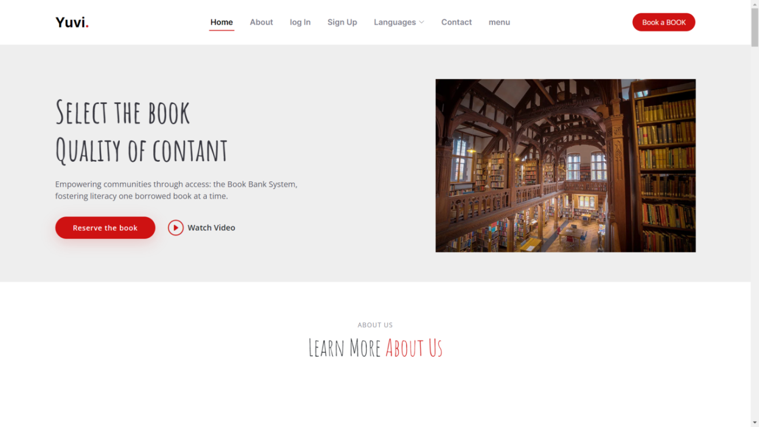

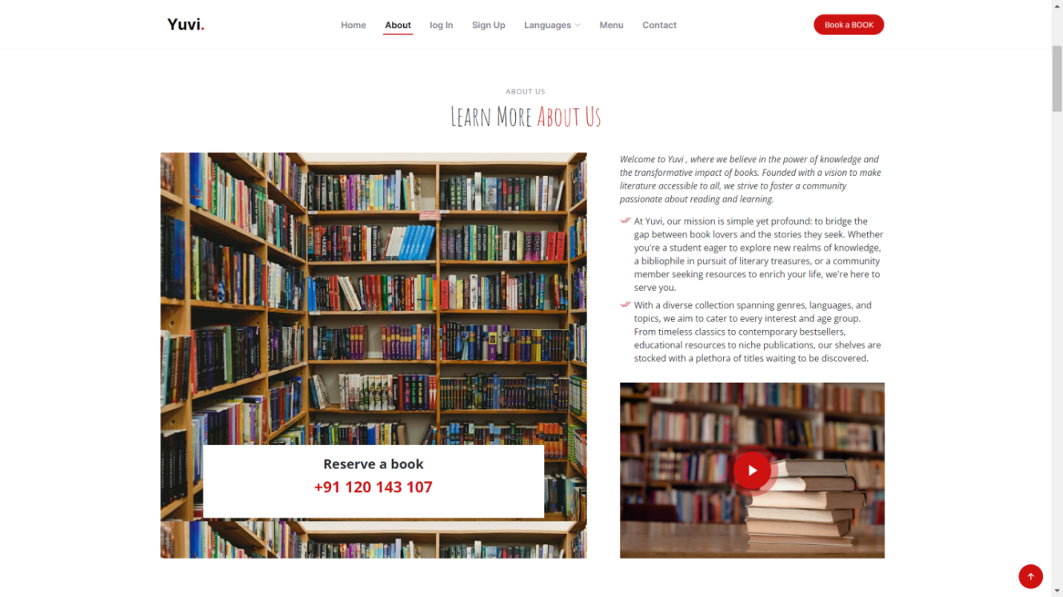

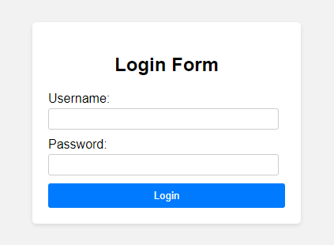

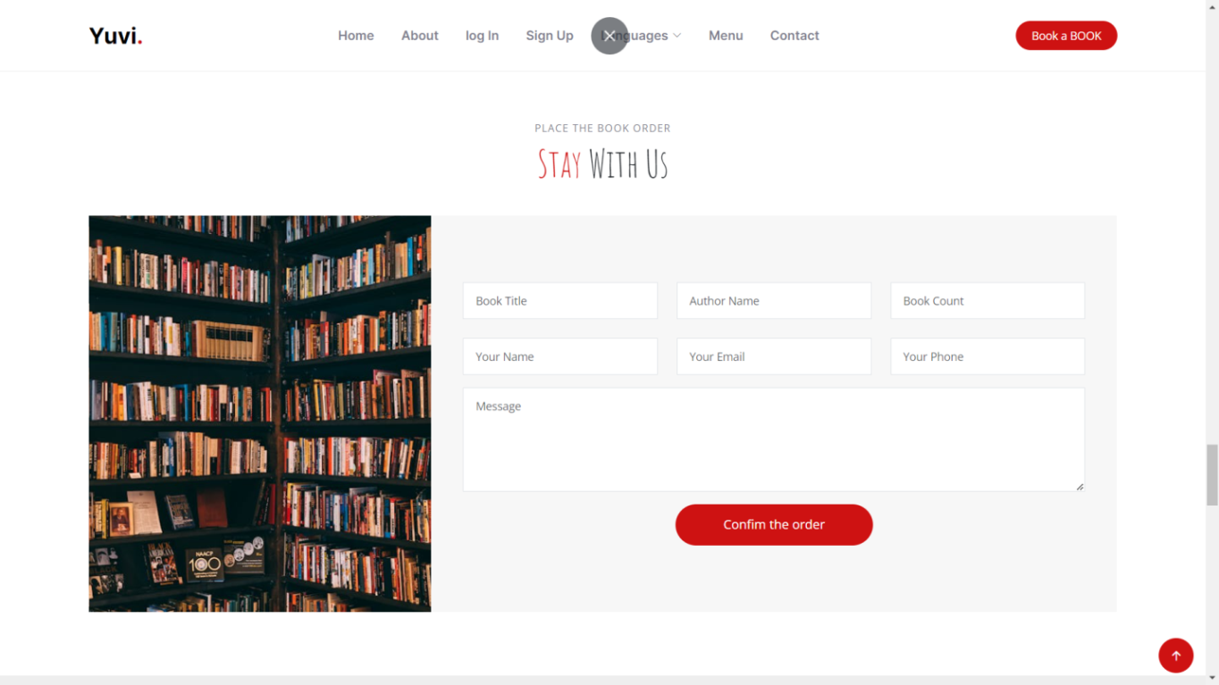

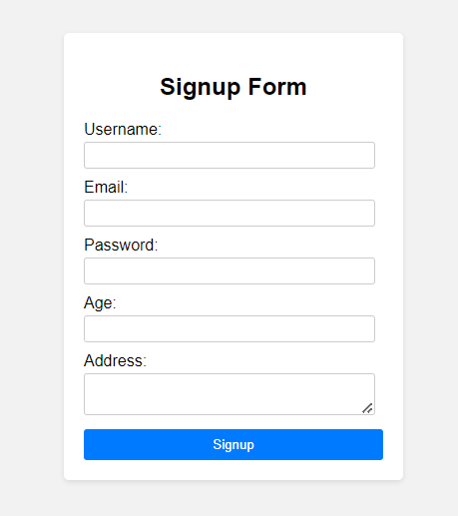

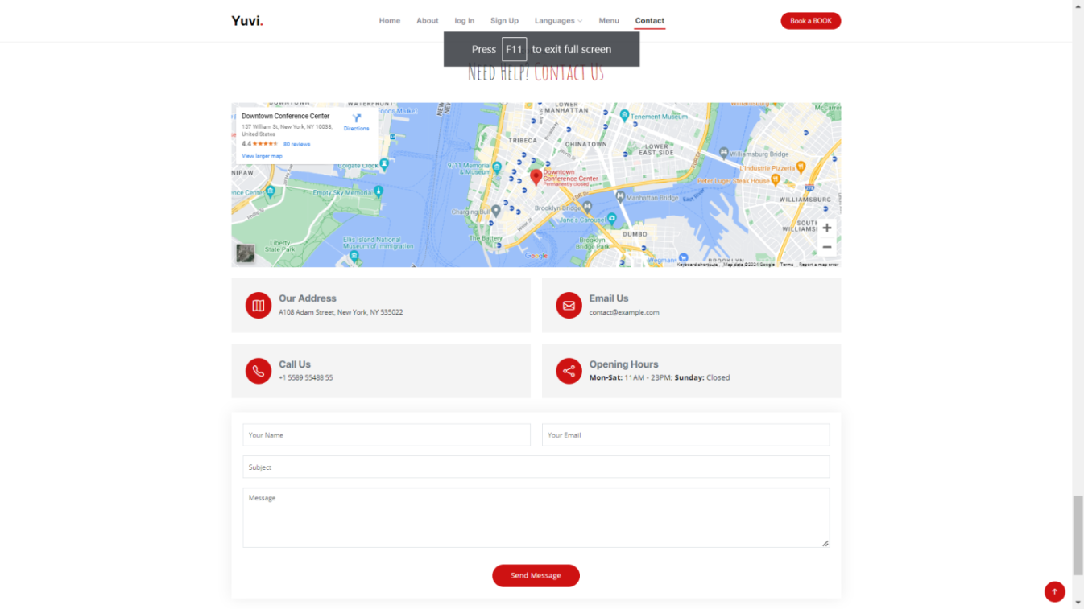

**Conclusion**

**Project Achievements:**

Summarize the key functionalities implemented in the online book bank reservation system.

**Limitations and Future Improvements:**

Discuss potential limitations of the current system and areas for future enhancements.

* **Examples:**

Integration with mobile payment gateways, advanced search functionalities, integration with library management systems.

**Project Impact and Benefits:**

Briefly mention the positive impact of the system on users and administrators, such as:

* Improved efficiency and accessibility
* Reduced administrative workload
* Enhanced data management and reporting capabilities

**Appendices**

**Detailed Code Snippets:**

Include relevant code snippets to illustrate specific functionalities or algorithms.

**System Configuration Details:**

Provide detailed configuration information for the server, database, and other software components.